Analysis of Stocks Assignment-2

Name: Pratap S

Reg Number: 22BCE9334

Slot: F1

Technique 2 and 4:

1. **Visualization**:
   * Plot time series data using libraries like Matplotlib or Seaborn to visualize trends, seasonality, and volatility.
   * Plot histograms, box plots, and scatter plots to gain insights into the distribution and relationships within the data.
2. **Autocorrelation and Partial Autocorrelation Analysis**:
   * Compute autocorrelation and partial autocorrelation functions to identify any significant lags in the time series data.
   * This helps in understanding the temporal dependencies within the data.

1. For better understanding of the stocks, a line plot is plotted using all the given stocks in the data.  
   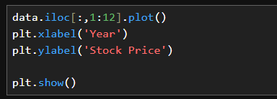  
     
   Output:  
   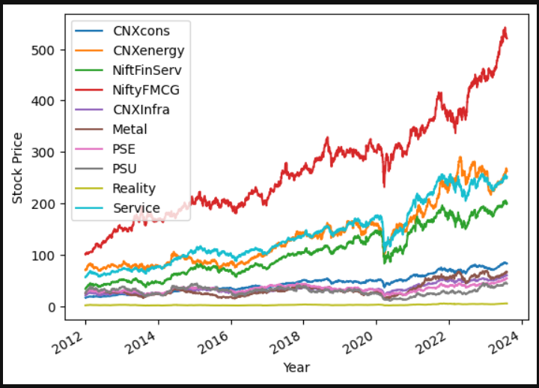
2. Creating Line plots using matplotlib library  
   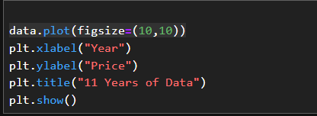  
     
   Output:  
   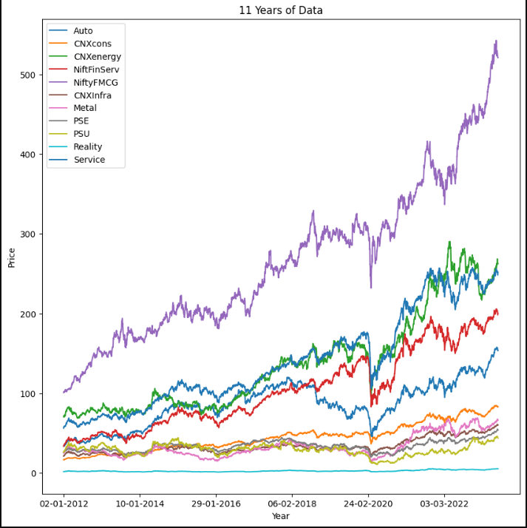
3. Finding the stocks at a current given price used.  
   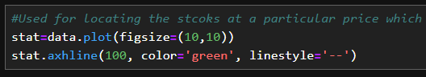  
     
     
     
     
     
     
     
     
     
     
   Output:  
   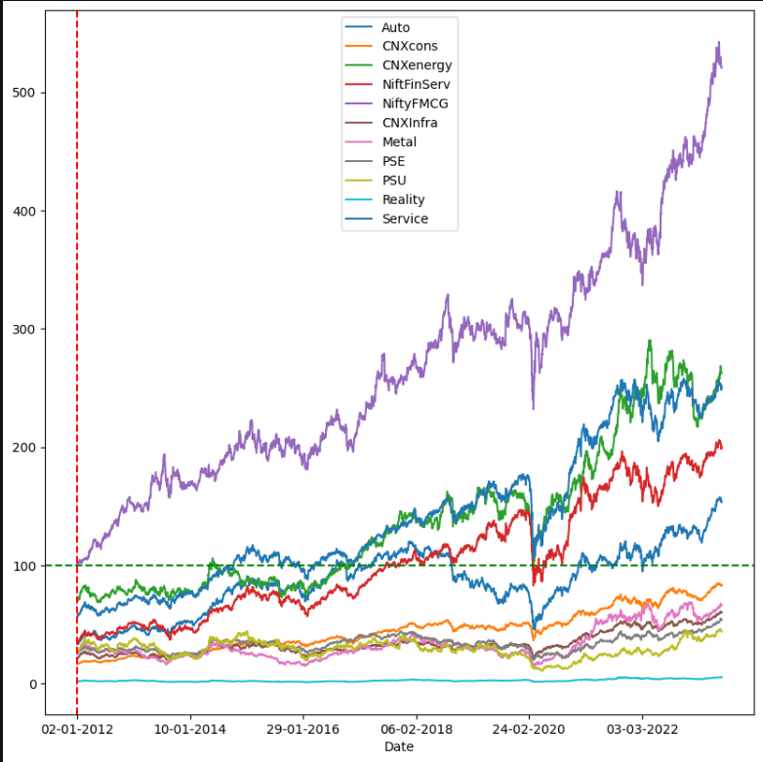
4. Finding aggreagates:  
   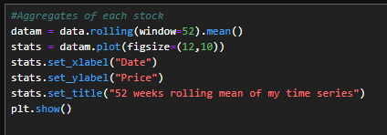  
     
   Output:  
   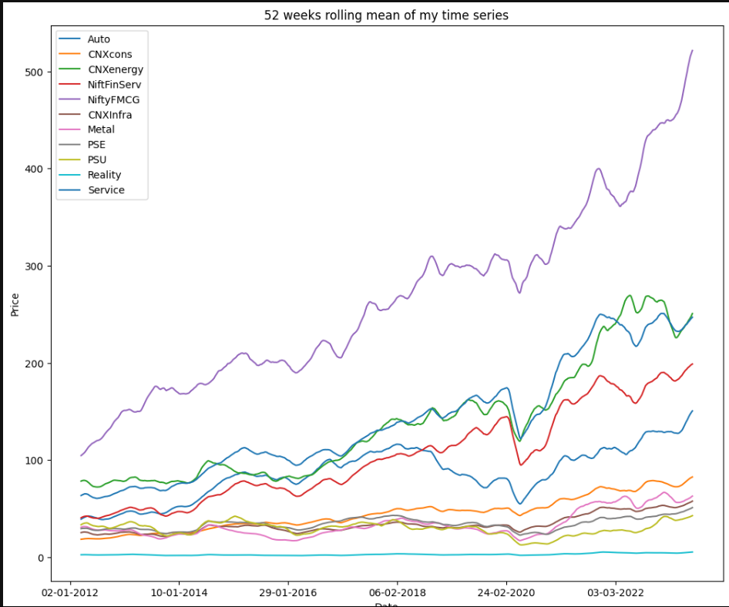
5. Boxplot:  
   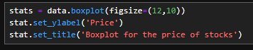  
   Output:  
   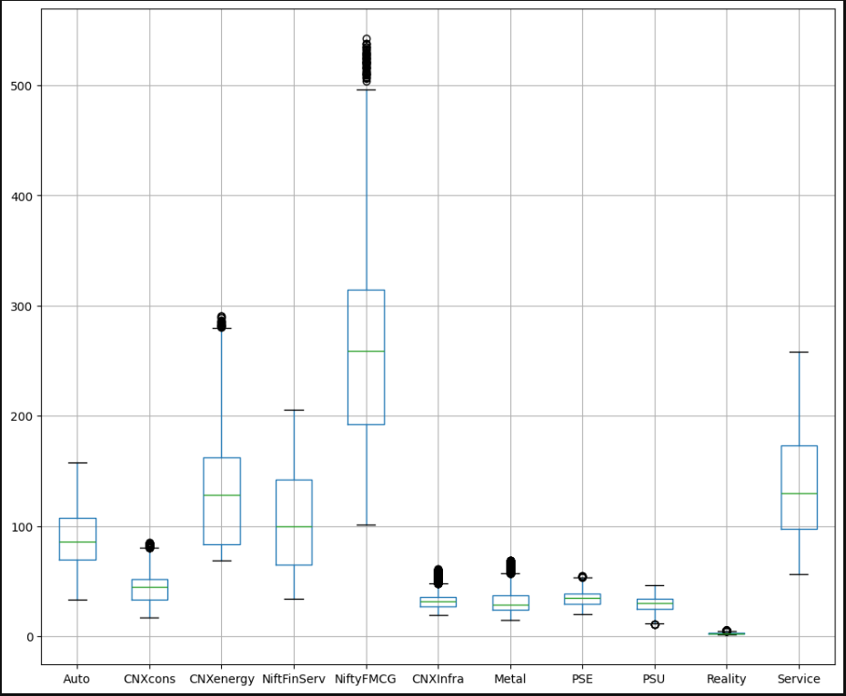
6. Histograms for all the 11 stocks:  
   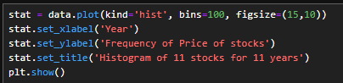  
     
   Output:  
   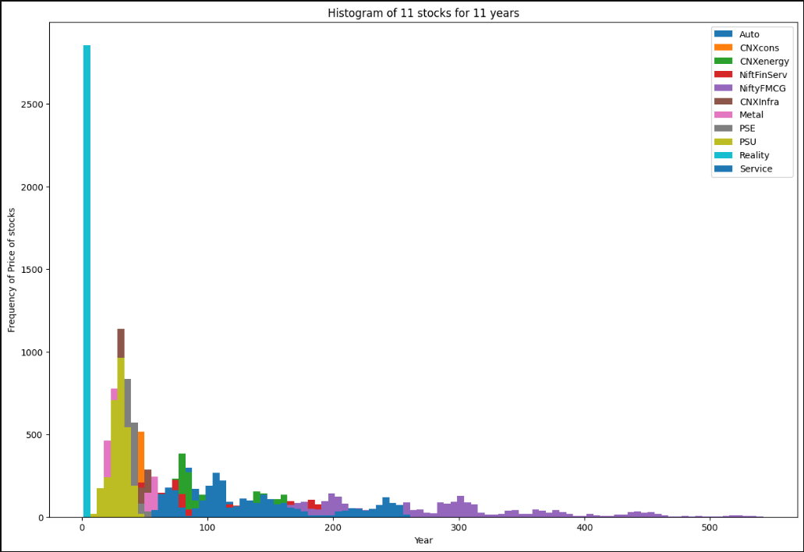
7. Autocorrelation using matplotlib:  
   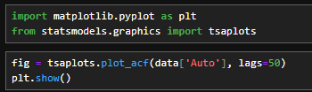  
   Similar to this, code is given for each stock as mentioned in the single quotes like in the above image.  
     
   Output:  
   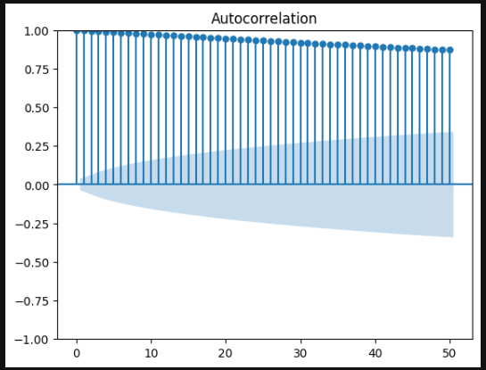
8. Partial Autocorrelation:  
     
     
     
   Similar to this, code is given for each stock as mentioned in the single quotes like in the above image.  
     
   Output:  
     
   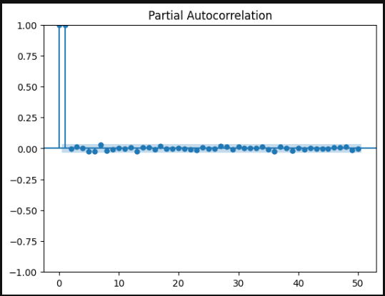
9. Decomposition of each 11 stocks for trends, seasonality and volatility  
   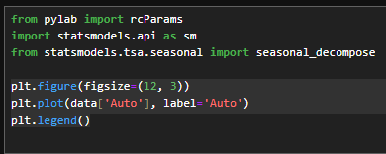  
     
   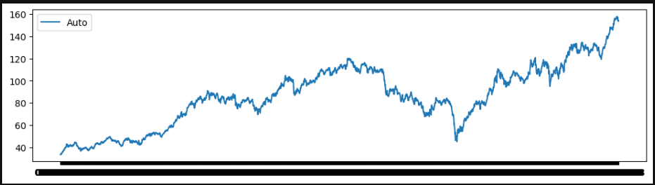
10. Sample moving average:  
      
      
      
    Output:  
    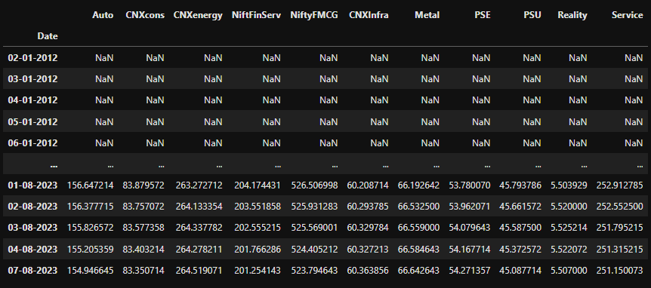
11. Exponential moving Average:  
      
      
      
    Output:  
      
    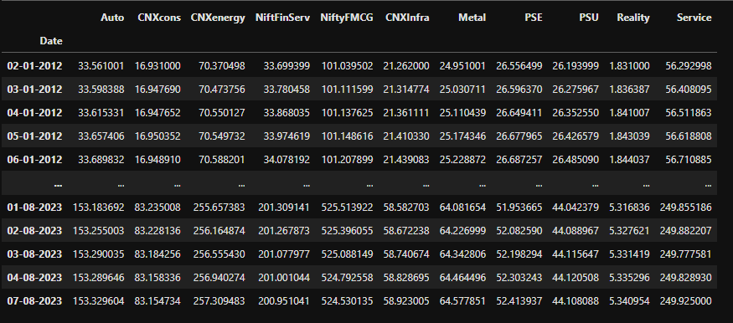
12. Time Series:  
      
    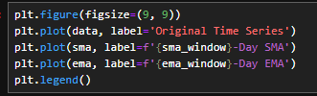  
      
    Output:  
      
    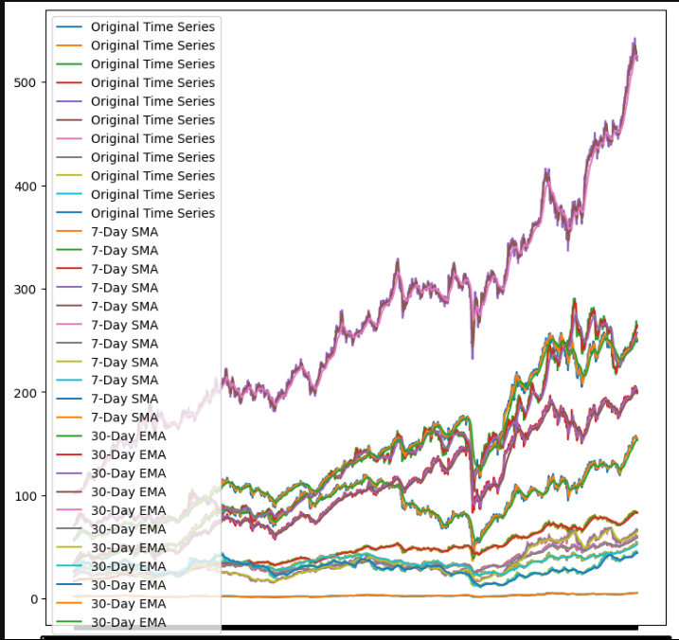

The Above assignment is attached in the teams assignment portal for refernce.

The above assignment is also available in my Github profile which is directed using the following link:  
<https://github.com/pratap834/stock_predict0r.git>